Exercise Summary

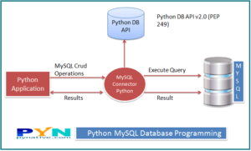

The blow is the modules I used to develop and integrate Python applications that work with a MySQL database server.

1. PyMySQL Connector Python is written in pure Python, and it is self-sufficient to execute database queries through python.

Furthermore, the following point below summarizes the steps in a succinct way;

1. I read the given file with Python scripts
2. Database for the exercise was created
3. I install MySQL Connector Python
4. I established Python MySQL Database Connection
5. I did a spot check on the connection and was able to
6. I use the Python MySQL SQL SELECT Query to retrieve data from a DB Table
7. Also, insert data into the database table
8. Then, I wrote some query (attached in the folder) to answer the exercise questions

Hence, in the exercise and with some reference from Stack overflow, I completed the exercise with the transaction management (MySQL Workbench), connection pooling, and error-handling techniques. This assisted me to develop the python programs that work with a MySQL database server.